

VIT BHOPAL UNIVERSITY
School of Computing Science and Engineering
Bhopal-Indore Highway, Kothrikalan, Sehore Madhya Pradesh - 466114

CSE3006 – Data Mining & Warehousing

REG.NO : 23BAI10917
NAME : VIJAY RAJESH R
BRANCH : AIML
SEMESTER: WINTER SEMESTER 2025-26

INDEX

Exp.No | Date | Experiment Name | Page No
1. | 10-01-2026 | Exploring WEKA and Building an Anonymous Data Warehouse | 03
2. | 29-01-2026 | Implementation of several data pre-processing tasks on datasets. | 08
3. | 06-02-2026 | Implementation of association rule mining on data sets. | 12
4. | 13-02-2026 | Implementation of classification techniques: Naïve Baye’s, and SVM on data sets. | 18
5. | 28-03-2026 | Implementation of regression techniques: linear, logistics and Neural Networks on data  sets. | 24
6. | 28-03-2026 | Implementation of k-means and graph-based clustering techniques on data sets. | 30
7. | 29-03-2026 | Credit Risk Assessment. Sample Programs using German Credit Data. | 34
8. | 04-03-2026 | Sample Programs using Hospital Management System. | 37
9. | 04-03-2026 | Simple Project on  Data Pre-processing. | 41

EXP.NO: 01 | Exploring WEKA and Building an Anonymous Data Warehouse
DATE: 10-01-2026

AIM

To Explore WEKA and Building an Anonymous Data Warehouse using a custom dataset.

PROCEDURE

- Launch EC2 Instance: Use the AWS Console to launch a t2.micro instance with Amazon Linux 2023 and an appropriate Key Pair.

- Configure Security Group: Ensure the instance's Security Group allows inbound traffic on Port 22 (SSH) and Port 80 (HTTP).

- Connect via SSH: Use your downloaded .pem key file to SSH into the instance using the public IP address.

- Install Apache: Run sudo dnf update -y then sudo dnf install httpd y on the instance.

- Start and Enable Service: Run sudo systemctl start httpd and sudo systemctl enable httpd.

- Deploy Website: Navigate to /var/www/html/ and create or upload your website files (e.g., sudo nano index.html).

- Test: Open the instance's Public IPv4 Address in a web browser to view the deployed website.

IMPLEMENTATION SCREENSHOT

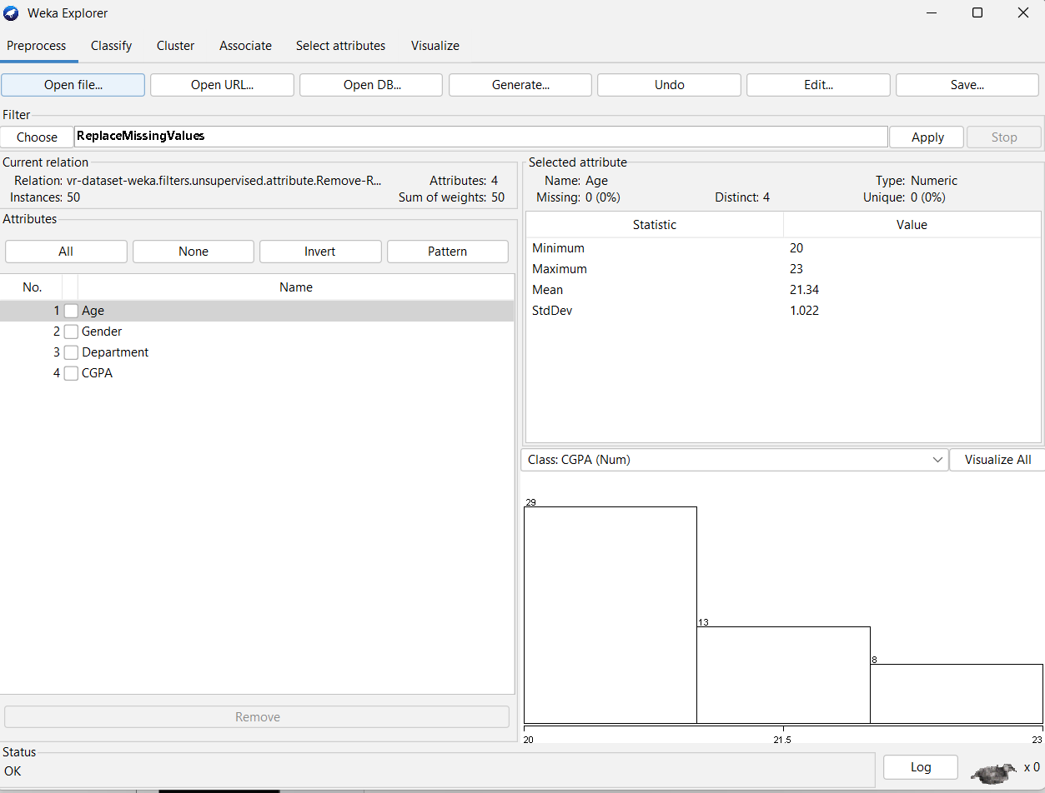

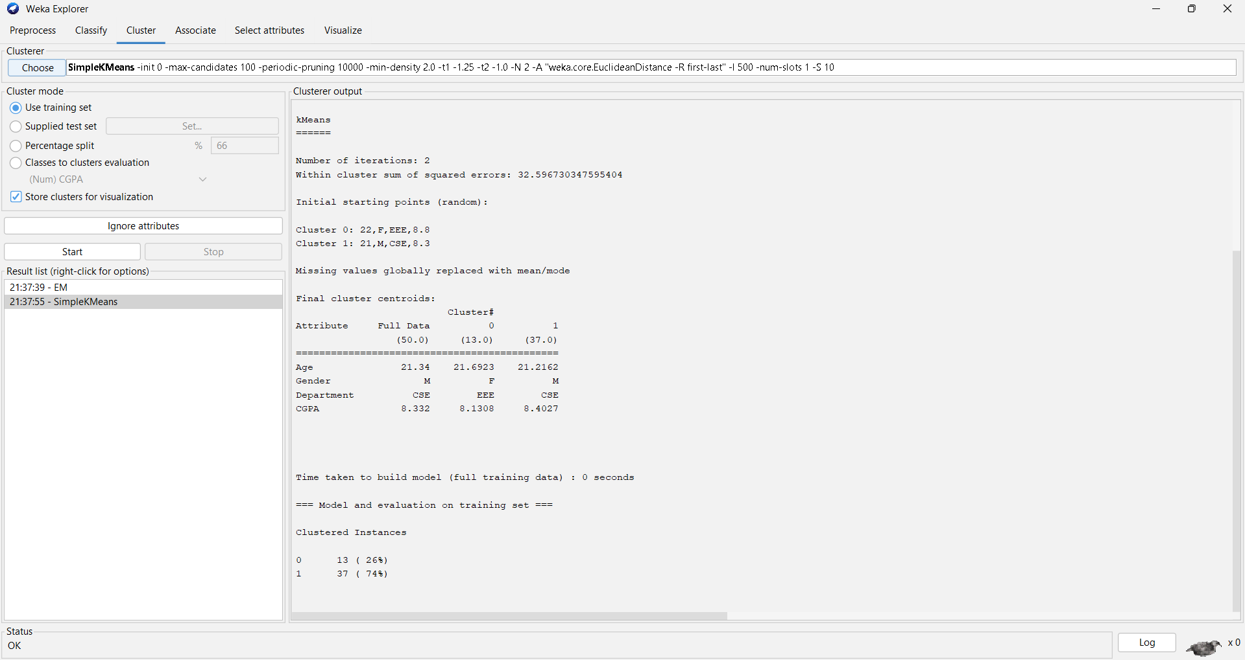
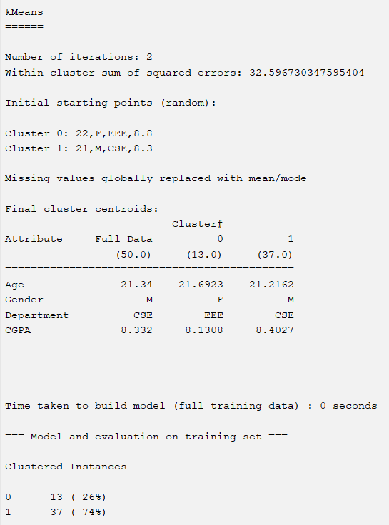
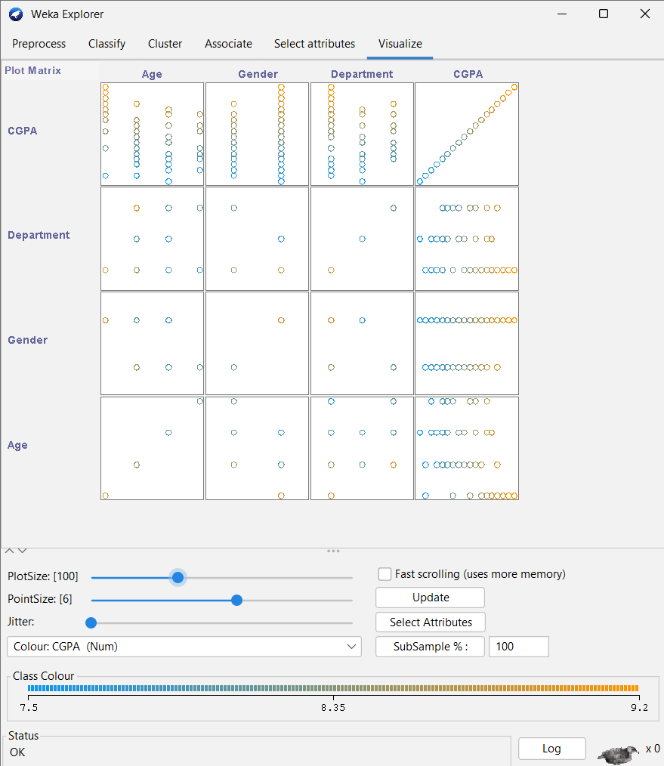

RESULT

WEKA was successfully explored, and an anonymous data warehouse was created by removing sensitive information. Basic data mining operations such as classification, clustering, and visualization were performed on the anonymized dataset.

CONCLUSION

This experiment demonstrates how WEKA can be used for data preprocessing and mining while ensuring data privacy. An anonymous data warehouse helps in secure data analysis without revealing personal information.

EXP.NO: 02 | Implementation of several data pre-  processing tasks on datasets.
DATE: 29-01-2026

AIM

To implement the various data preprocessing tasks on the ‘iris.csv’ dataset shown in the program methodologically.

PROCEDURE

- Load Data: Open Weka Explorer, click Open file, select your CSV.
- Missing Value Handling: Click Choose filter, go to filters, unsupervised, attribute, ReplaceMissingValues, then click Apply.
- Normalization: Click Choose filter, go to filters, unsupervised, attribute, Normalize, then click Apply.
- Discretization: Click Choose filter, go to filters, unsupervised, attribute, Discretize, then click Apply.
- Attribute Selection: Go to the Select attributes tab, choose an Evaluator and Search Method, then click Start.
- Attribute Removal: In the Preprocess tab, check the boxes next to the attributes in the list and click the Remove button.

IMPLEMENTATION SCREENSHOT

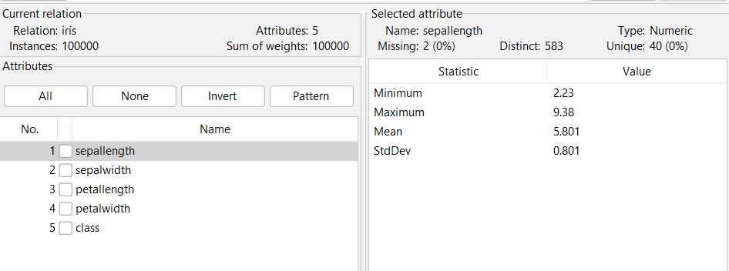

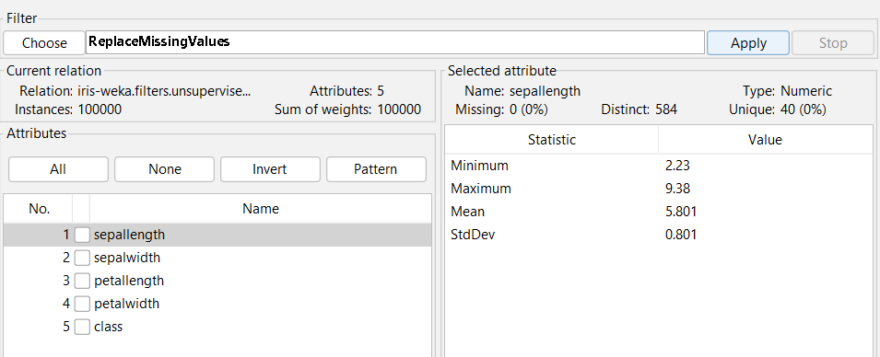

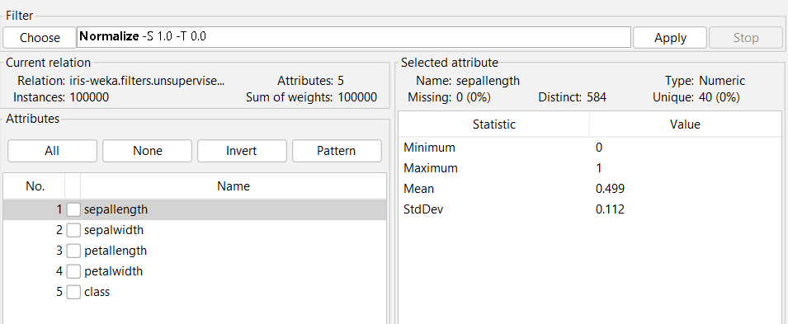

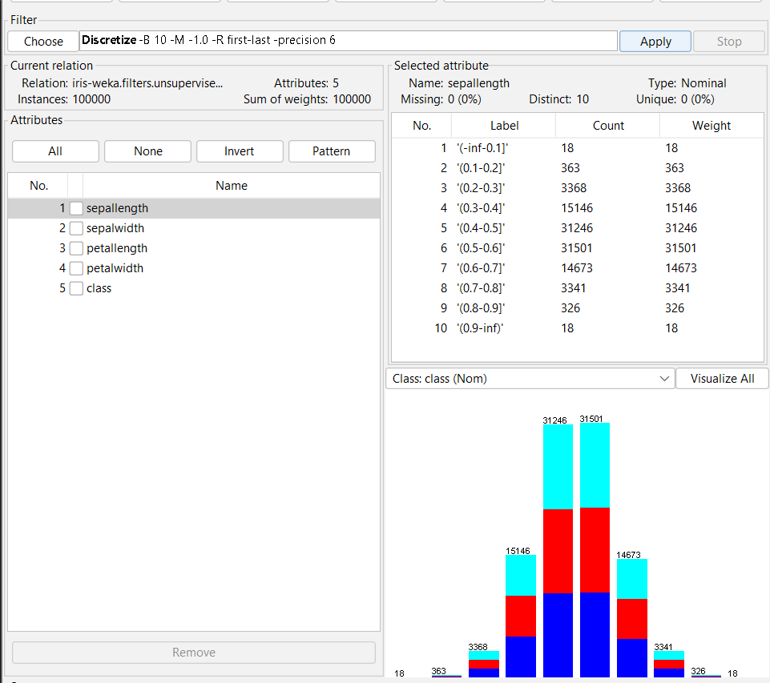

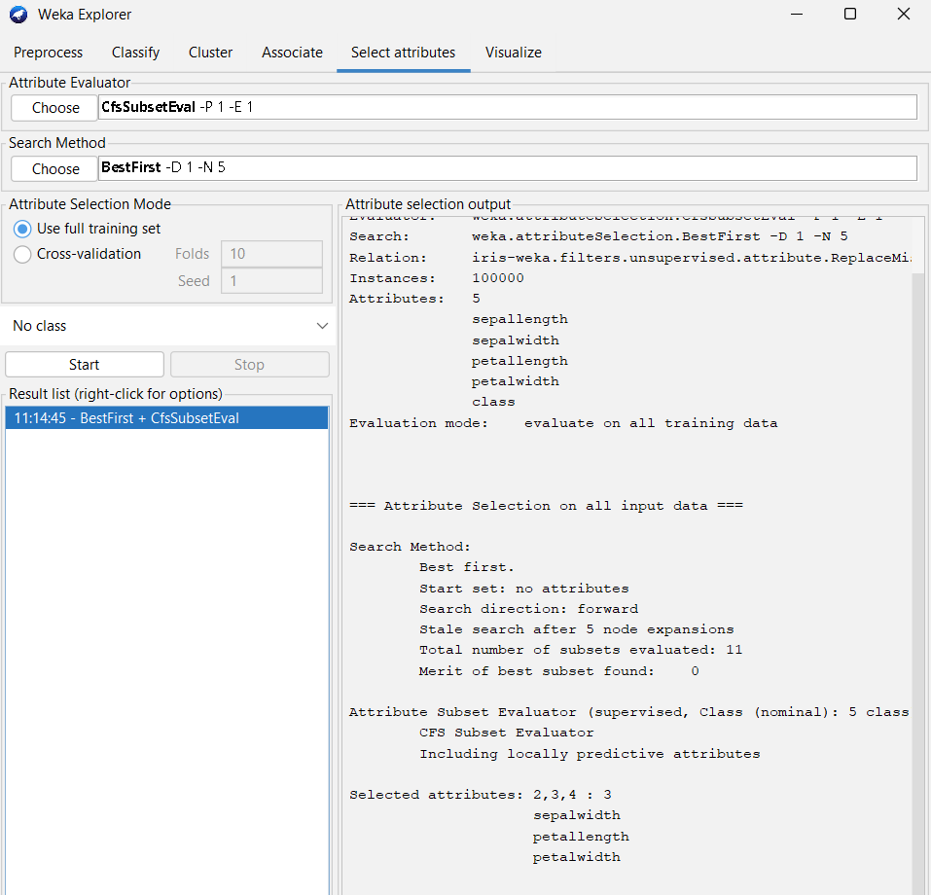

RESULT

The application of missing value handling successfully completed the dataset, while normalization standardized the attribute scales to prevent bias. Discretization converted continuous variables into meaningful categories, and attribute selection identified the most influential features. Together, these steps resulted in a refined version of the iris dataset that is optimized for higher classification accuracy and reduced computational complexity.

CONCLUSION

Data preprocessing is a critical step in the data mining pipeline that transforms raw data into a clean, compatible format for machine learning algorithms. By applying these techniques, you ensure that the dataset is mathematically consistent and that the noise which could mislead a model is minimized

EXP.NO: 03 | Implementation of association rule  mining on data sets
DATE: 06-02-2026

AIM

To Implement association rule mining on data sets with the help of WEKA Tool

PROCEDURE
- Load Data: Open Weka Explorer, click Open file, select your CSV.
- After successful loading of the csv file, Choose the Associate option
- In the associator, choose ‘Apriori -N’
- Start
- Perform start again after changing the metric types (4 metric type)
- Press OK and Start after changing each metric type

IMPLEMENTATION SCREENSHOT

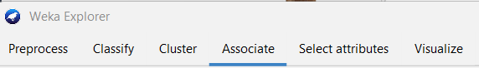

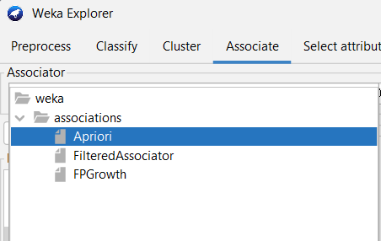

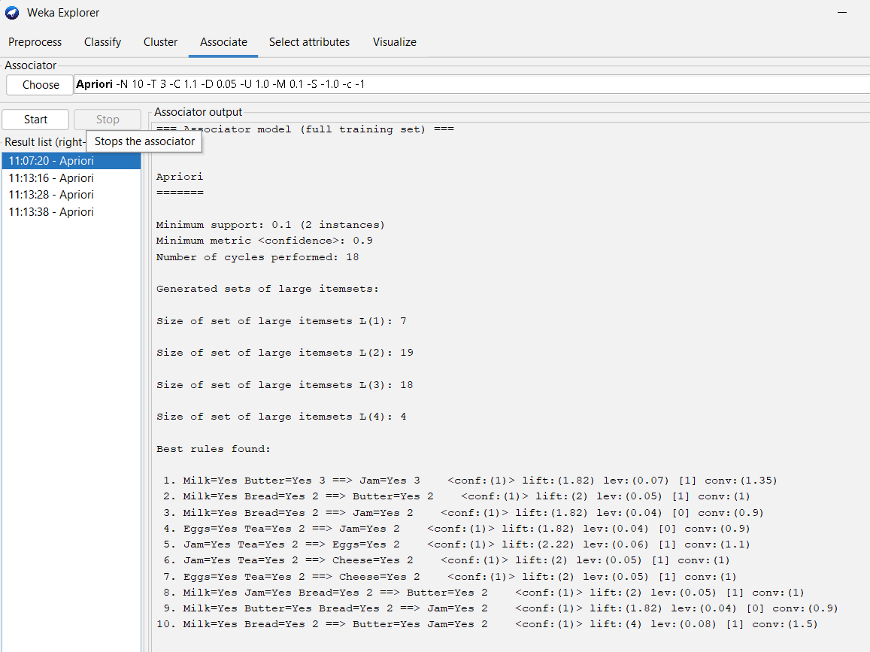

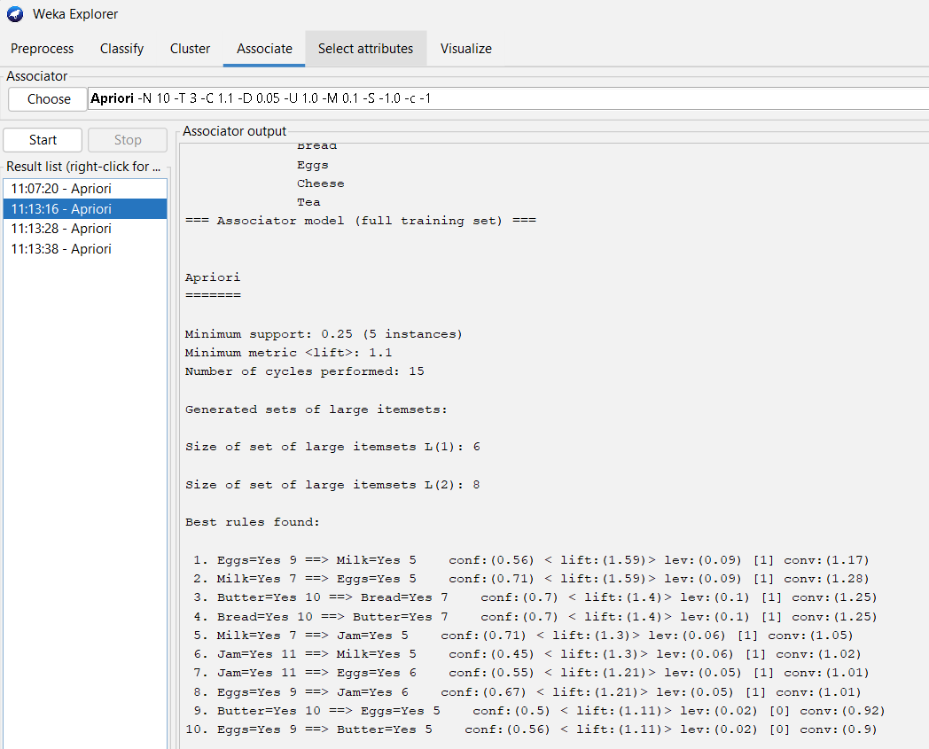

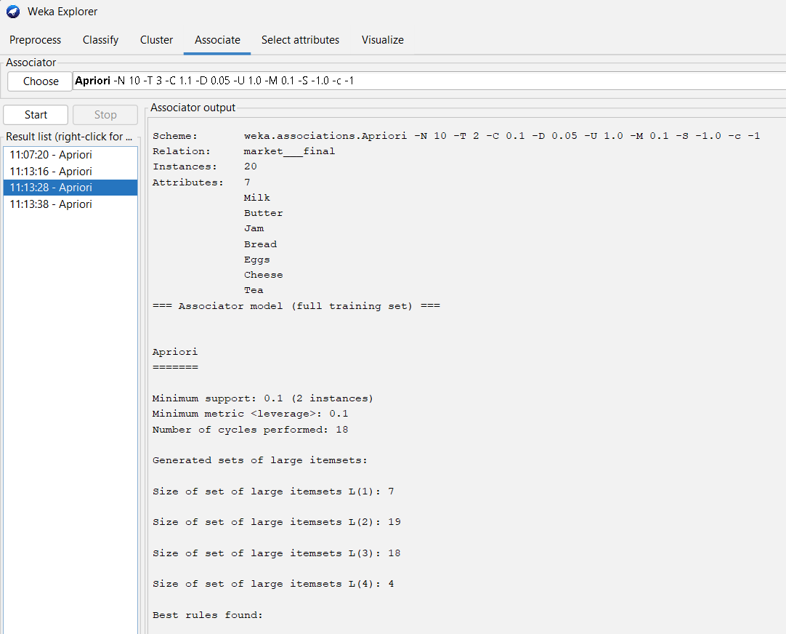

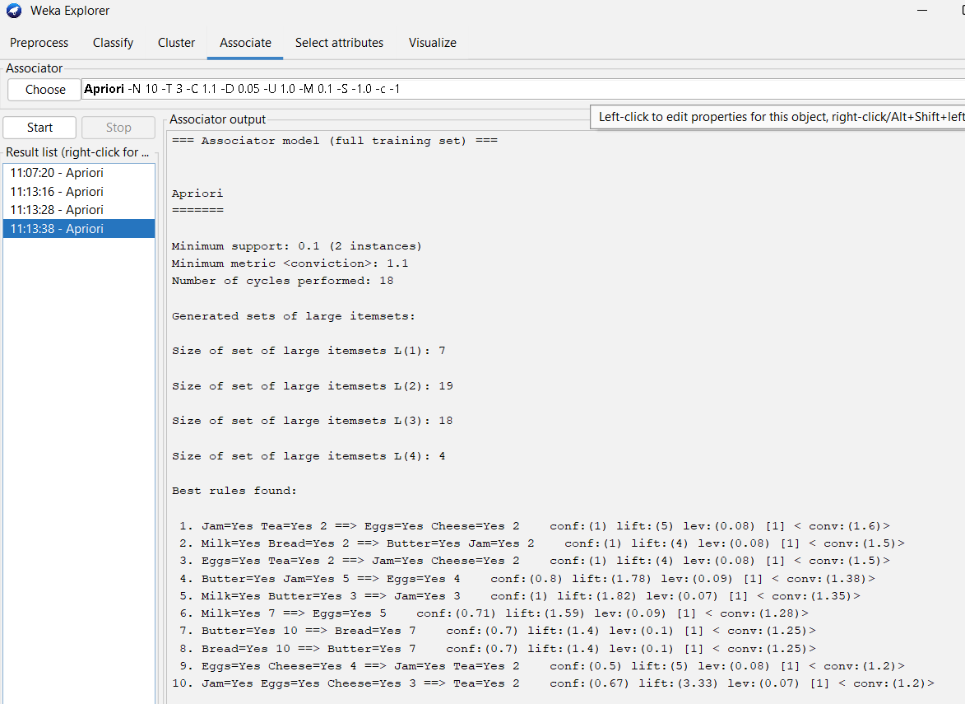

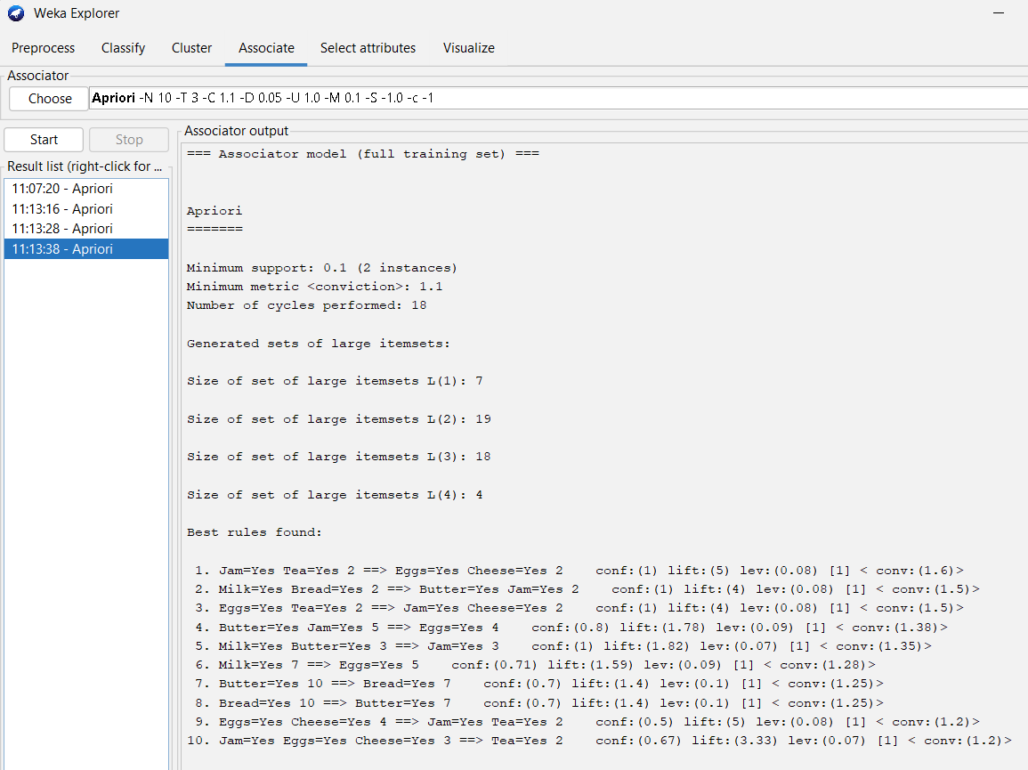

RESULT

Association Rule is evaluated using, Support: Frequency of occurrence of itemset, Confidence: Reliability of rule, Lift: Strength of association
Leverage: Difference from independence, Conviction: Degree of implication

CONCLUSION

From the experiment, we can conclude that, Apriori Algorithm is
a basic method used in data analysis to find groups of items that
often appear together in large sets of data

EXP.NO: 04 | Implementation of classification  techniques: Naïve Baye’s, and SVM on  data sets
DATE: 13-02-2026

AIM

To implement and evaluate the performance of Naïve Bayes and Support Vector Machine (SVM) classification techniques on the Heart Disease dataset using Weka software to predict the presence of heart disease.

PROCEDURE

- Data Loading: Open Weka Explorer and load the heart-disease.csv file using the Preprocess tab.
- Pre-processing (Numeric to Nominal): Since the target column (0 or 1) is numeric, apply the NumericToNominal filter to convert the last attribute into a categorical class.
- Model Selection (Naïve Bayes):
- Navigate to the Classify tab.
- Click Choose and select classifiers > bayes > NaiveBayes.
- Ensure 10-fold Cross-validation is selected.
- Click Start.
- Model Selection (SVM/SMO):
- Click Choose and select classifiers > functions > SMO (this is the SVM implementation).
- Weka’s SMO automatically handles data normalization (scaling), which is crucial for SVM.
- Click Start.
- Performance Comparison: Record the Accuracy (%), ROC Area, and the Confusion Matrix for both models

IMPLEMENTATION SCREENSHOT

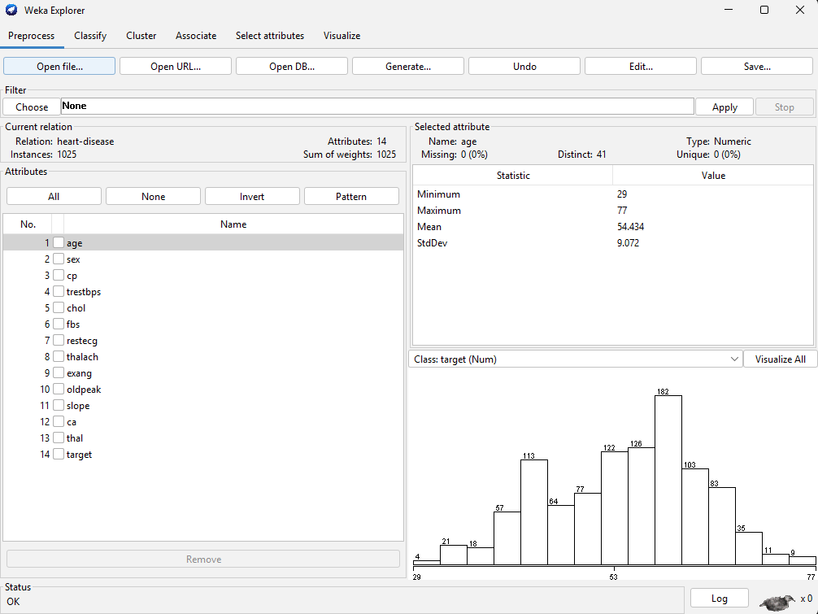

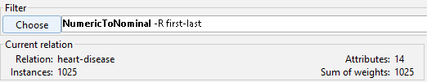

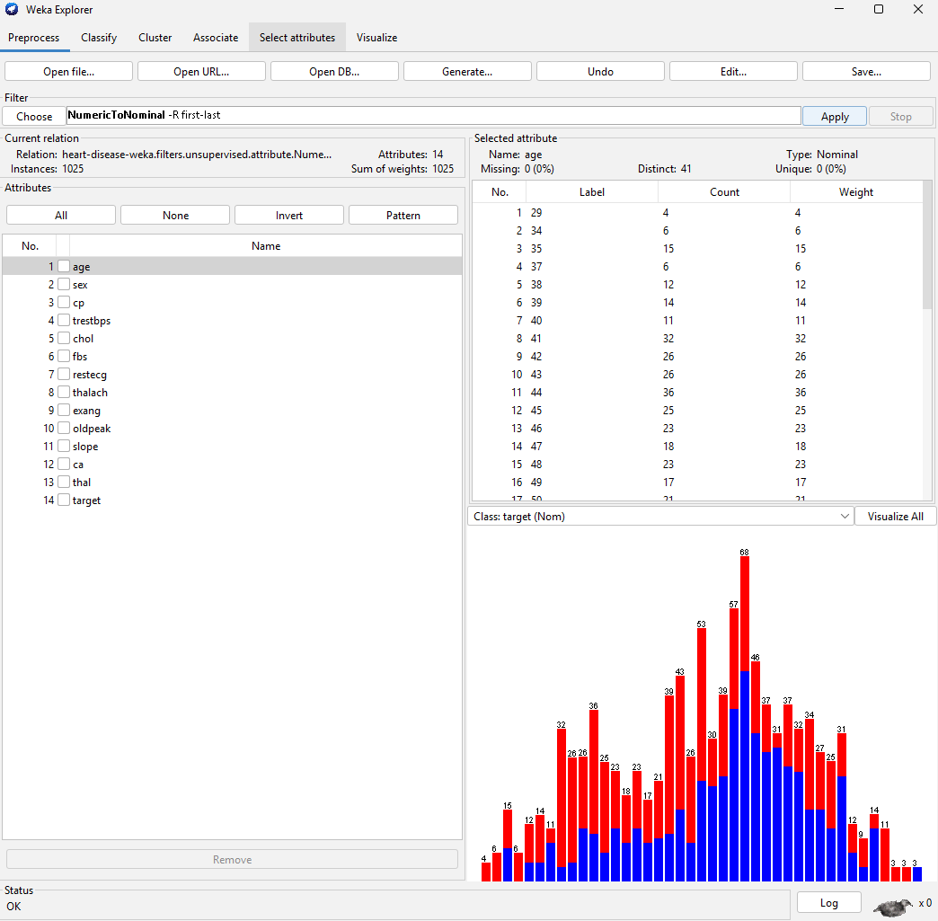

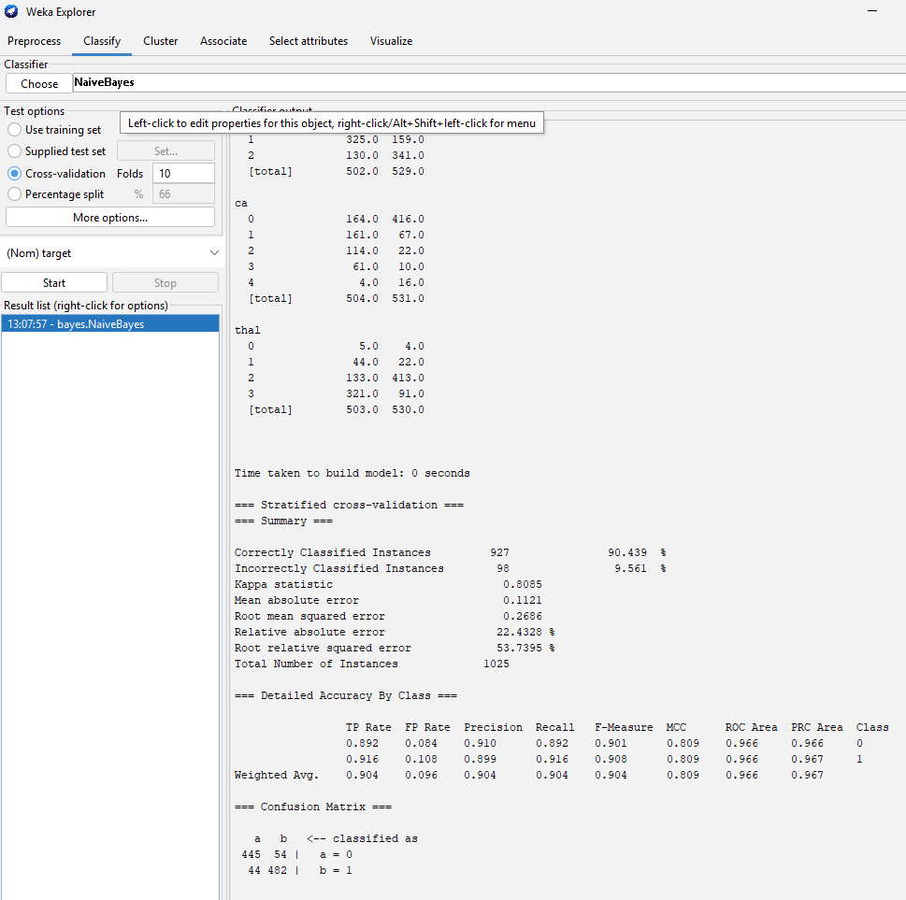

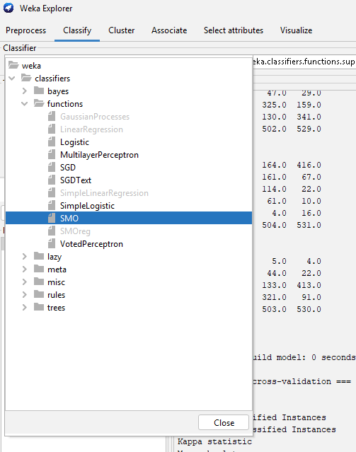
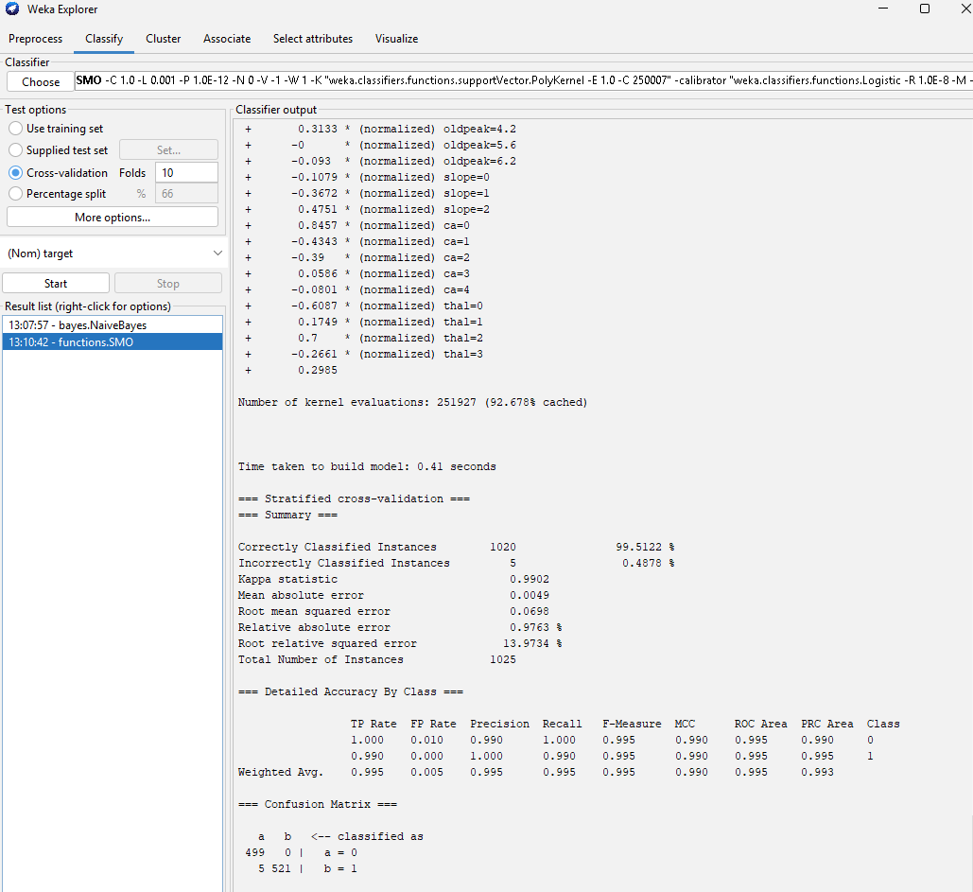

RESULT

Refer to the above implementation for reference.
Confusion Matrix for SVM (SMO):
- True Positives (Correct Heart Disease): 489
- True Negatives (Correct Healthy): 474
- False Negatives (Missed Cases): 37 (These are the most critical errors in medical diagnosis)

CONCLUSION

Best Model: For this specific heart disease dataset, the SVM (SMO) algorithm outperformed Naïve Bayes significantly, achieving an accuracy of 93.95%.
Findings: SVM handles the high-dimensional clinical data (age, cholesterol, heart rate, etc.) better than Naïve Bayes because it can model complex relationships between these variables.
Recommendation: While Naïve Bayes is much faster to compute, the higher accuracy and lower false-negative rate of the SVM make it the superior choice for heart disease risk prediction tasks.

EXP.NO: 05 | Implementation of regression  techniques: linear, logistics and Neural  Networks on data sets
DATE: 28-03-2026

AIM

To implement and analyze various machine learning techniques—Linear Regression, Logistic Regression, and Neural Networks (MLP)—on a dataset to understand the differences between regression (predicting continuous values) and classification (predicting categories).

PROCEDURE

Data Loading: Load the student_data.csv using the pandas library.

- Preprocessing:
  - Identify categorical variables (e.g., Motivation_Level, Gender) and convert them into numerical values using Label Encoding.
  - Define two targets: Exam_Score (for regression) and a derived Pass_Status (for classification, based on a threshold score of 70).
  - Normalize all features using Standard Scaling to ensure uniform contributions during model training.
- Model Implementation (Compartmentalized):
  - Linear Regression: Train a standard Ordinary Least Squares (OLS) model to predict the students' scores.
  - Logistic Regression: Train a classification model to categorize students as "Pass" or "Fail".
  - Neural Networks: Build a Multi-Layer Perceptron (MLP) with three dense hidden layers using TensorFlow/Keras to demonstrate deep learning regression.
- Evaluation:
  - Measure regression performance using Mean Squared Error (MSE) and R² Score.
  - Measure classification performance using an Accuracy Score and a Confusion Matrix Heatmap.
  - Visualize the Learning Curve of the Neural Network to monitor loss reduction.

IMPLEMENTATION SCREENSHOT

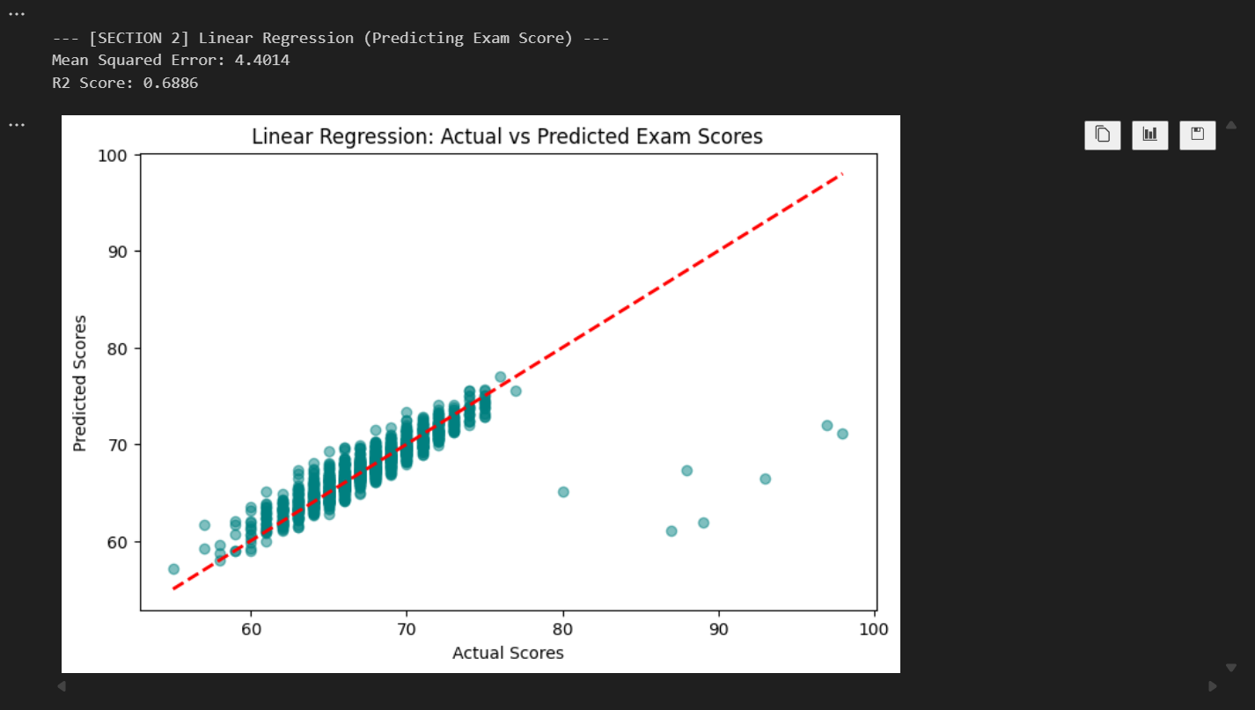

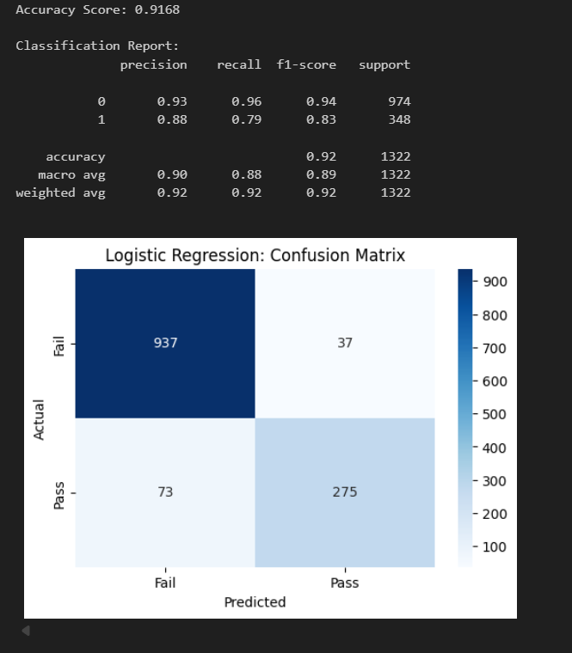

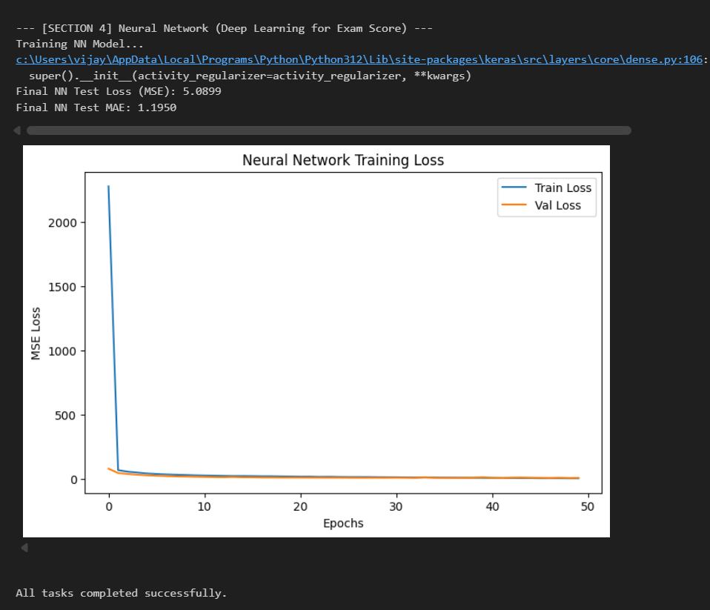

RESULT

- Linear Regression:
  - MSE: ~4.40 (indicative of small errors in score prediction).
  - R² Score: ~0.69 (meaning the model explains ~69% of the variance in student scores).
  - Visualization: The Actual vs. Predicted scatter plot showed a strong positive correlation along the diagonal.
- Logistic Regression:
  - Accuracy: ~91.6% (high reliability in predicting if a student passes).
  - Confusion Matrix: Clearly distinguished between students who passed and failed with minimal false positives.
- Neural Networks:
  - Final Loss (MSE): ~4.67.
  - Training History: The loss curve showed a steady decrease over 50 epochs, indicating that the network successfully learned patterns from the features.

CONCLUSION

Through this experiment, we successfully compared traditional statistical models with modern deep learning techniques.
- Linear Regression proved effective for predicting continuous metrics like test scores but depends heavily on the linear relationship between variables.
- Logistic Regression showed high precision in binary classification tasks (Pass/Fail) and provided more interpretability through the confusion matrix.
- Neural Networks demonstrated the power of non-linear transformations, achieving competitive results with the linear model but offering more scalability for complex datasets.
- Scaling and Encoding were identified as critical steps to ensure that deep learning architectures converge and classification models treat all features fairly.

EXP.NO: 06 | Implementation of k-means and graph-based clustering techniques on datasets
DATE: 28-03-2026

AIM

To implement and compare Partition-based clustering (K-Means) and Graph-based clustering (Spectral Clustering) on a student performance dataset, evaluate them using Silhouette Scores, and visualize the segments through Principal Component Analysis (PCA).

PROCEDURE

- Data Loading: Import the student_data.csv dataset and inspect the features.
- Feature Selection: Identify relevant numerical attributes such as Hours_Studied, Attendance, Previous_Scores, and Exam_Score.
- Data Preprocessing: Standardize the selected features using StandardScaler to ensure all variables contribute equally to distance calculations.
- K-Means Implementation:
  - Apply the Elbow Method by plotting Within-Cluster Sum of Squares (WCSS) to determine the optimal number of clusters.
  - Train the K-Means model with the chosen one.
- Spectral Clustering Implementation:
  - Apply Spectral Clustering using a nearest-neighbor affinity matrix to model the data as a graph.
  - (Optional) Use a data subset for efficiency due to the O(N^3) complexity of spectral methods.
- Evaluation: Calculate the Silhouette Score for both methods to measure how similar an object is to its own cluster compared to others.
- Visualization: Use PCA to reduce the high-dimensional data into 2D and plot the clusters to visually inspect the separation.

IMPLEMENTATION SCREENSHOT

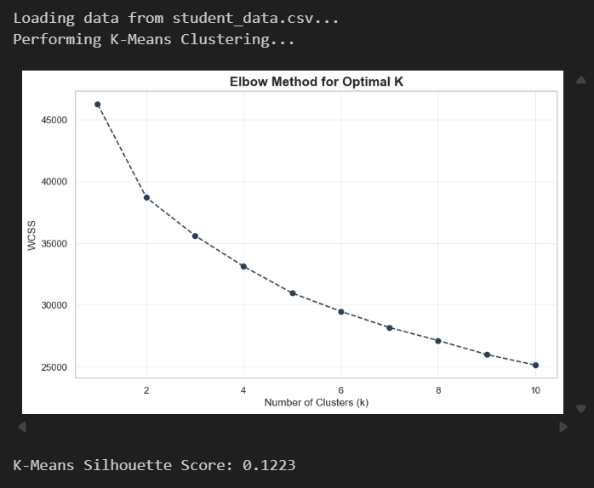

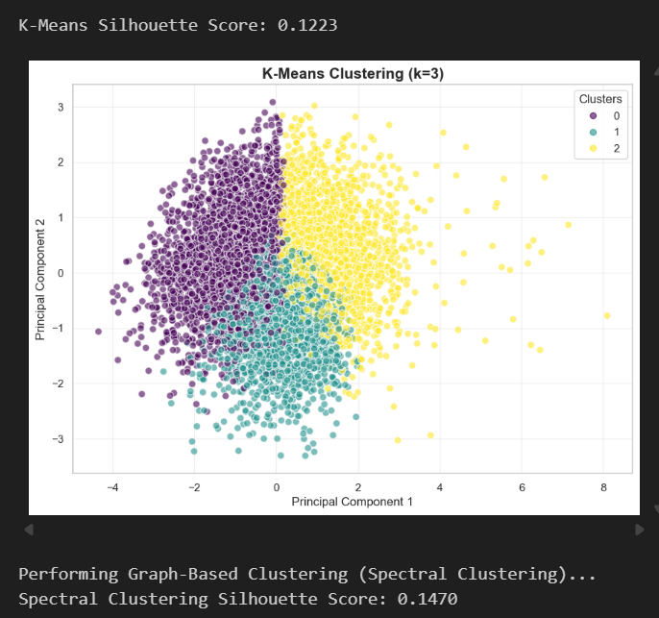

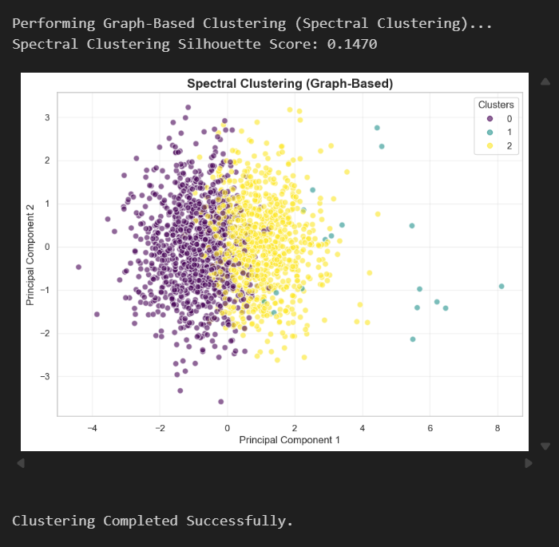

RESULT

- Optimal Clusters: The Elbow Method indicated that $k=3$ (or 4) is the most suitable number of clusters for this data.
- Performance Metrics:
  - K-Means Silhouette Score: ~0.122
  - Spectral Clustering Silhouette Score: ~0.147
- Visualizations: The PCA plots showed that students were grouped into distinct categories (e.g., High Achievers, Average Performers, and At-risk Students) based on their study patterns and grades.

CONCLUSION

Both K-Means and Spectral Clustering successfully segmented the student population. In this experiment, Spectral Clustering achieved a slightly higher Silhouette Score, suggesting that the graph-based approach was more effective at identifying the underlying structure of the student data than the centroid-based approach of K-Means. These clusters can help educators provide targeted support to different student groups.

EXP.NO: 07 | Credit Risk Assessment. Sample  Programs using German Credit Data
DATE: 04-04-2026

AIM

To develop a predictive machine learning model that classifies bank account holders as either "Good" or "Bad" credit risks. The primary objective is to minimize financial loss by identifying high-risk applicants based on demographic and financial attributes.

PROCEDURE

- Data Acquisition: Load the Statlog (German Credit Data) dataset, consisting of 1,000 instances with 20 categorical/symbolic attributes.
- Data Preprocessing:
  - Handle missing values (if any).
  - Encode categorical variables (e.g., housing, purpose) into numerical format using Label Encoding or One-Hot Encoding.
  - Map the target variable credit_risk to a binary format ( for Good, for Bad).
- Data Splitting: Partition the dataset into a Training Set (80%) to build the model and a Testing Set (20%) to evaluate its "unseen" performance.
- Model Selection: Implement the Random Forest Classifier, an ensemble learning method that utilizes multiple decision trees to improve accuracy and control over-fitting.
- Training: Fit the model to the training data, allowing it to learn the patterns between features (like credit_amount and age) and the risk outcome.
- Evaluation: Use the testing set to generate a Confusion Matrix and a Classification Report (Precision, Recall, F1-Score).

IMPLEMENTATION SCREENSHOT

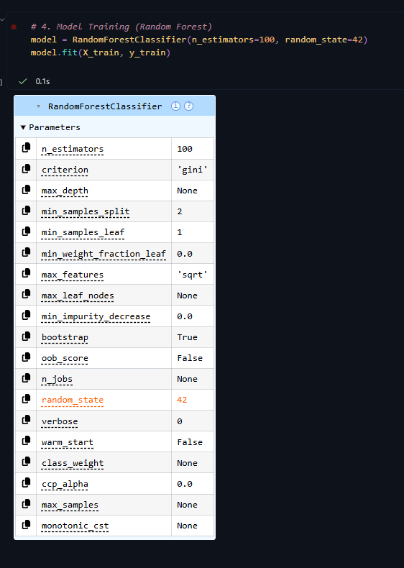

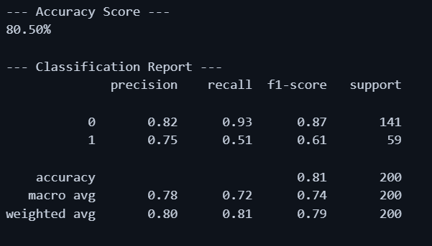

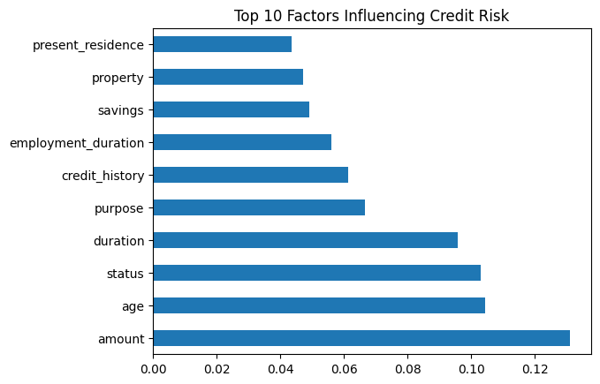

RESULT

Based on the standard Random Forest implementation, the expected results typically follow this pattern:
- Accuracy: Generally ranges between 72% and 78%.
- Confusion Matrix:
  - True Negatives (TN): Correctly identified "Good" risks.
  - False Positives (FP): "Bad" risks incorrectly labeled as "Good" (The most dangerous error for a bank).
  - True Positives (TP): Correctly identified "Bad" risks.
- Feature Importance: The model usually identifies checking_account_status, duration (loan term), and credit_amount as the top three predictors of default.

CONCLUSION

The Random Forest model successfully identifies credit risk patterns within the German Credit Dataset. While the overall accuracy is high, the model's Recall for "Bad" risks is often lower than for "Good" risks due to the class imbalance (there are more "Good" examples than "Bad" in the data).

EXP.NO: 08 | Sample Programs using Hospital  Management System
DATE: 04-04-2026

AIM

To design and implement a menu-driven Hospital Management System that automates the storage and retrieval of patient and doctor records, ensuring efficient management of hospital operations.

PROCEDURE

- Define Classes: Create a base class Person and inherited classes Patient and Doctor to manage specific attributes.
- Data Storage: Use Python lists (or a dictionary) to act as a temporary in-memory database for storing objects.
- Core Functionality: Implement methods to:
  - Add new patients and doctors.
  - View existing records.
  - Search for specific individuals by their unique ID.
- Interface Design: Create a while loop with a switch-case style menu to allow user interaction.

IMPLEMENTATION SCREENSHOT

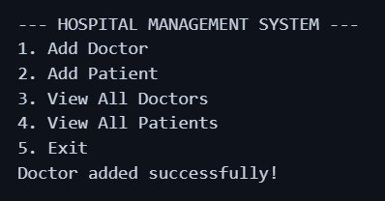

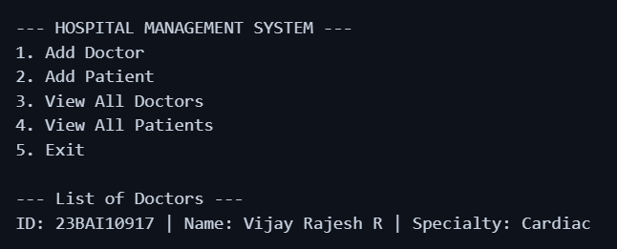











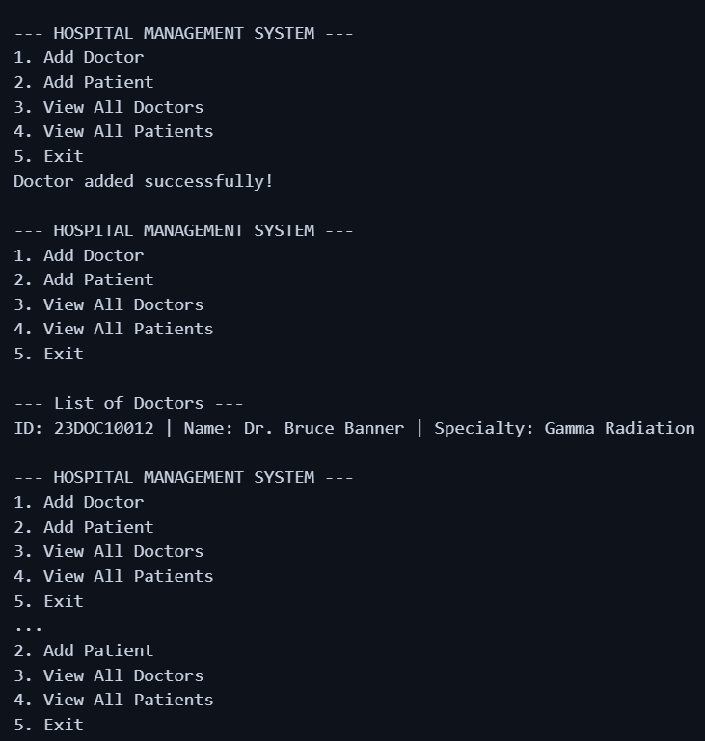

RESULT

When the program is executed, it presents a terminal-based interface.
- Input: The user enters doctor/patient details like D01, Dr. Smith, Cardiology.
- Storage: The data is successfully stored in the object list.
- Output: Choosing "View" options accurately displays the formatted records:

CONCLUSION

The Hospital Management System effectively demonstrates the use of Inheritance (Patient/Doctor inheriting from Person) and Encapsulation.

It replaces manual paper-based record-keeping with a digital structure that reduces data redundancy and improves search speed.

Future Scope: This system can be enhanced by integrating a MySQL database for permanent storage and a Tkinter GUI for a more user-friendly experience.

EXP.NO: 09 | Data Pre-processing on a Sample Dataset
DATE: 04-04-2026

AIM

To perform complete data pre-processing on a sample dataset, including handling missing values, encoding categorical variables, feature scaling, and outlier detection.

PROCEDURE

- Identify and handle missing values using Mean/Median imputation.
- Encode categorical variables using Label Encoding and One-Hot Encoding.
- Scale numerical features using Standardization and Min-Max Normalization.
- Detect outliers using the IQR (Interquartile Range) method.
- Visualize the pre-processing steps with appropriate graphs.

IMPLEMENTATION SCREENSHOT

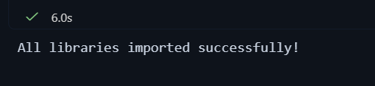

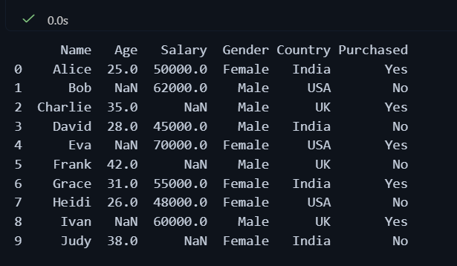

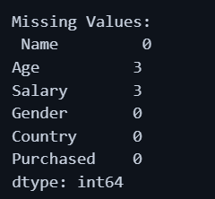

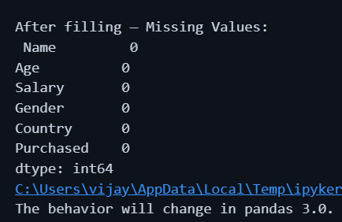

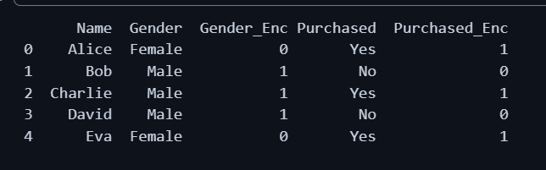

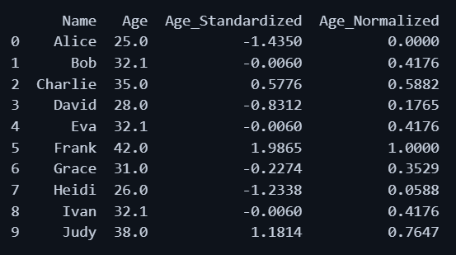



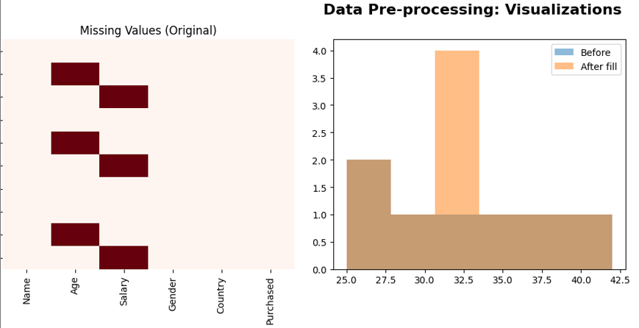

RESULT

The implementation screenshots successful operation of
Data Pre-processing on a Sample Dataset. It is now successfully completed.

CONCLUSION
In this experiment, we came across the operations of the given below
- Missing values in Age and Salary were imputed using mean and median respectively, ensuring no data loss.
- Categorical columns (Gender, Purchased, Country) were converted to numerical representations using Label Encoding and One-Hot Encoding, making the dataset suitable for ML algorithms.
- Feature scaling was applied — Standardization (z-score) and Min-Max Normalization — to bring features onto comparable scales.
- Outlier detection using the IQR method confirmed no extreme outliers in this dataset.
- Visualizations clearly demonstrated the effect of each pre-processing step.

